Steps to MongoDb

1.Install Mongodb
2.Run the mongod and start the mongo service
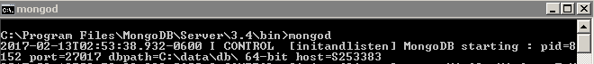
3.In another command prompt, run mongo and create “nmleapevents” database
use nmleapevents
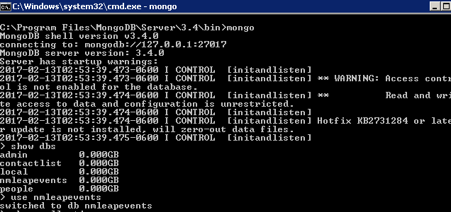

4. Run below commands on the mongo
db.createCollection(“boards”);
db.createCollection(“notes”);

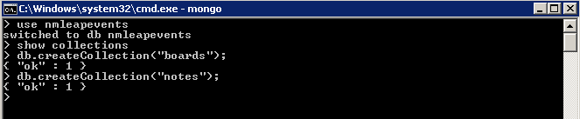
5. Check the below two collections are created
show collections
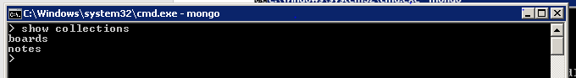

Steps to ReactJs frontend
- Install Node.js (https://nodejs.org/en/) please ignore if you have already installed
- Install Npm: npm install -g npm please ignore if you have already installed
- Install Webpack: npm install -g webpack
- copy the Code\mobile-practice-dashboard folder to local machine folder and in that folder from command prompt
- run npm install
- run npm start

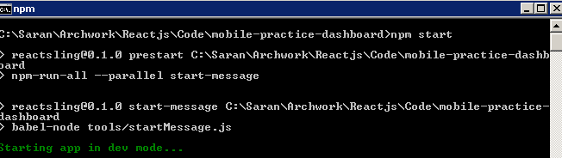

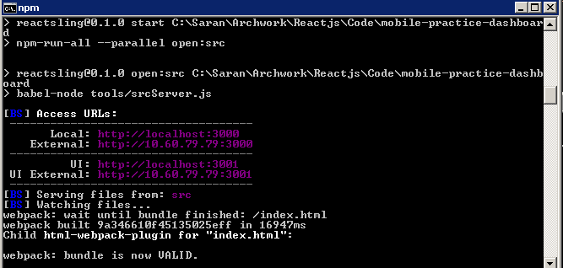

- Now access application from link http://localhost:3000/ in webbrowser

